Tutorial 1-1 WageCalculator.exe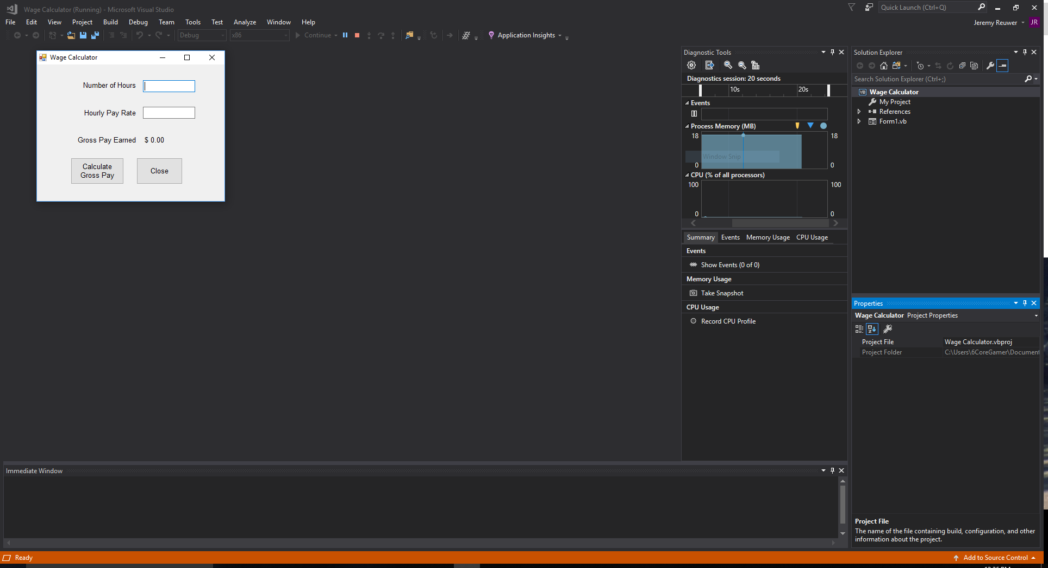

Tutorial 1-2 WageCalculator.exe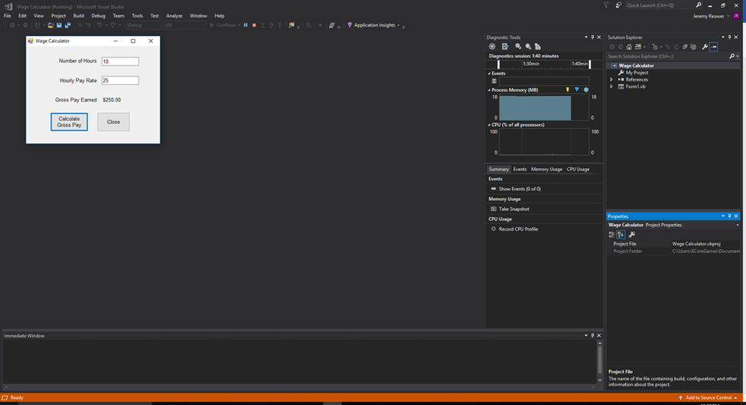

Tutorial 1-3 Controls Demo.exe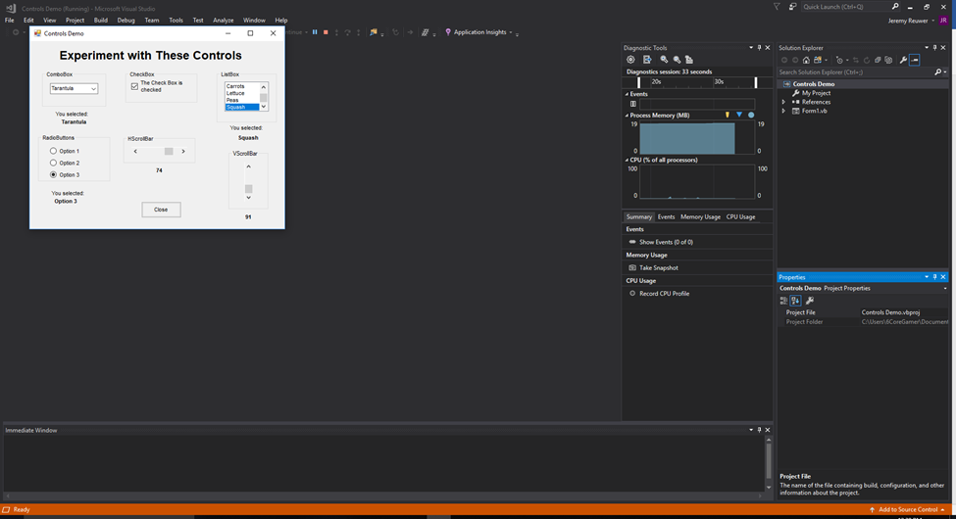

Tutorial 1-4 Get Started/ Start Page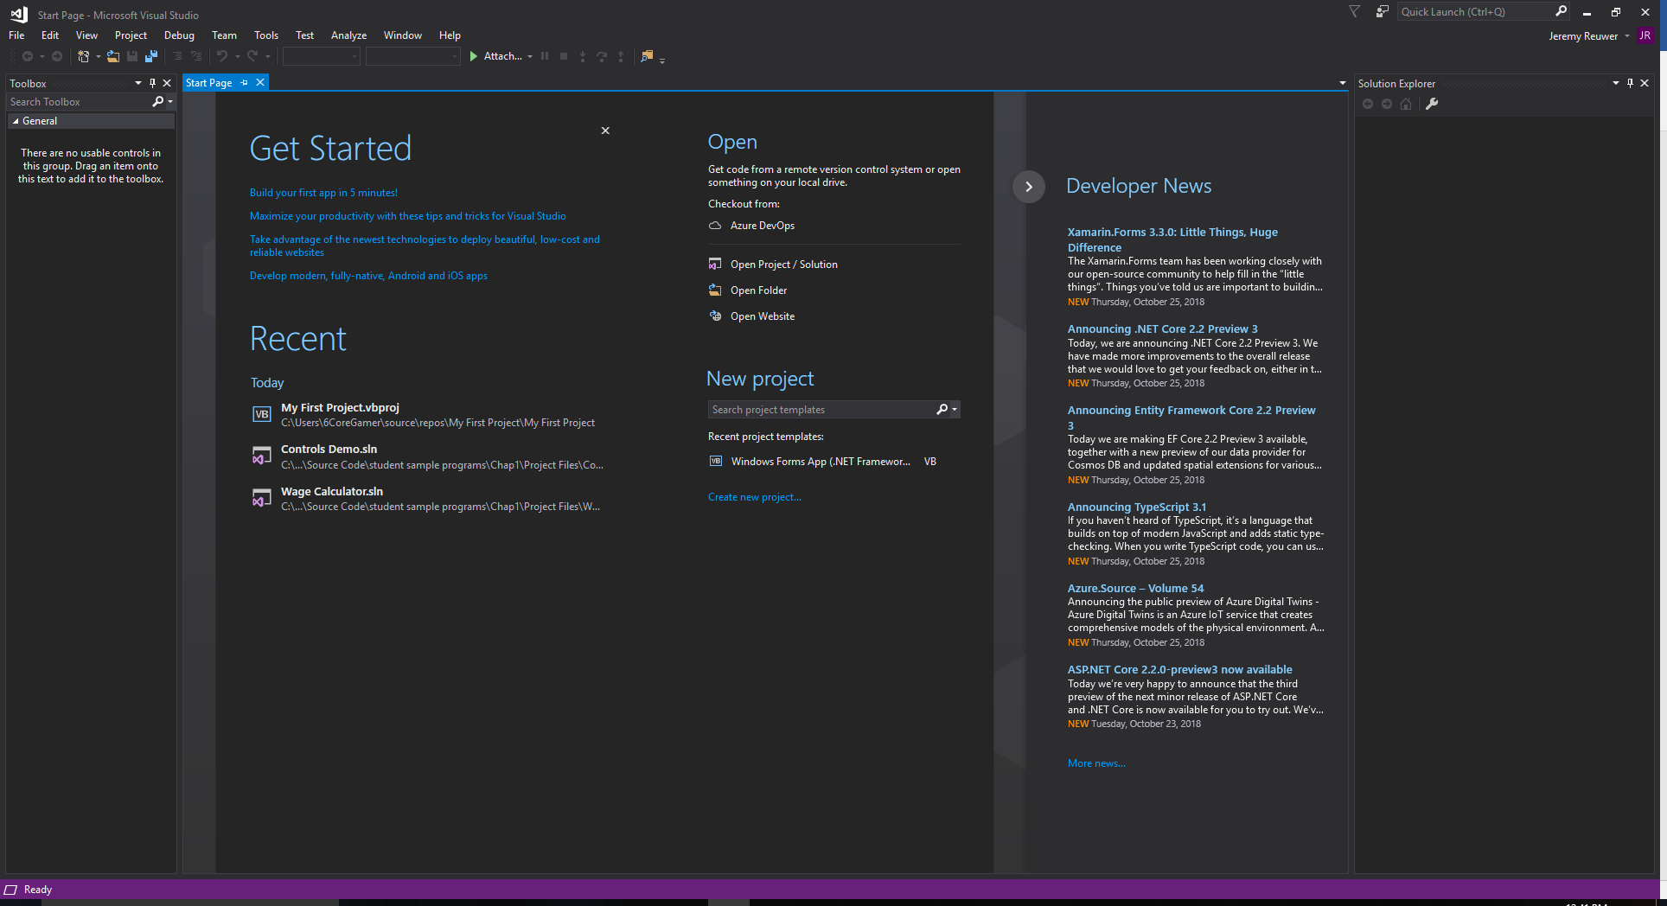

Tutorial 1-4 Get Started/Resetting the window layout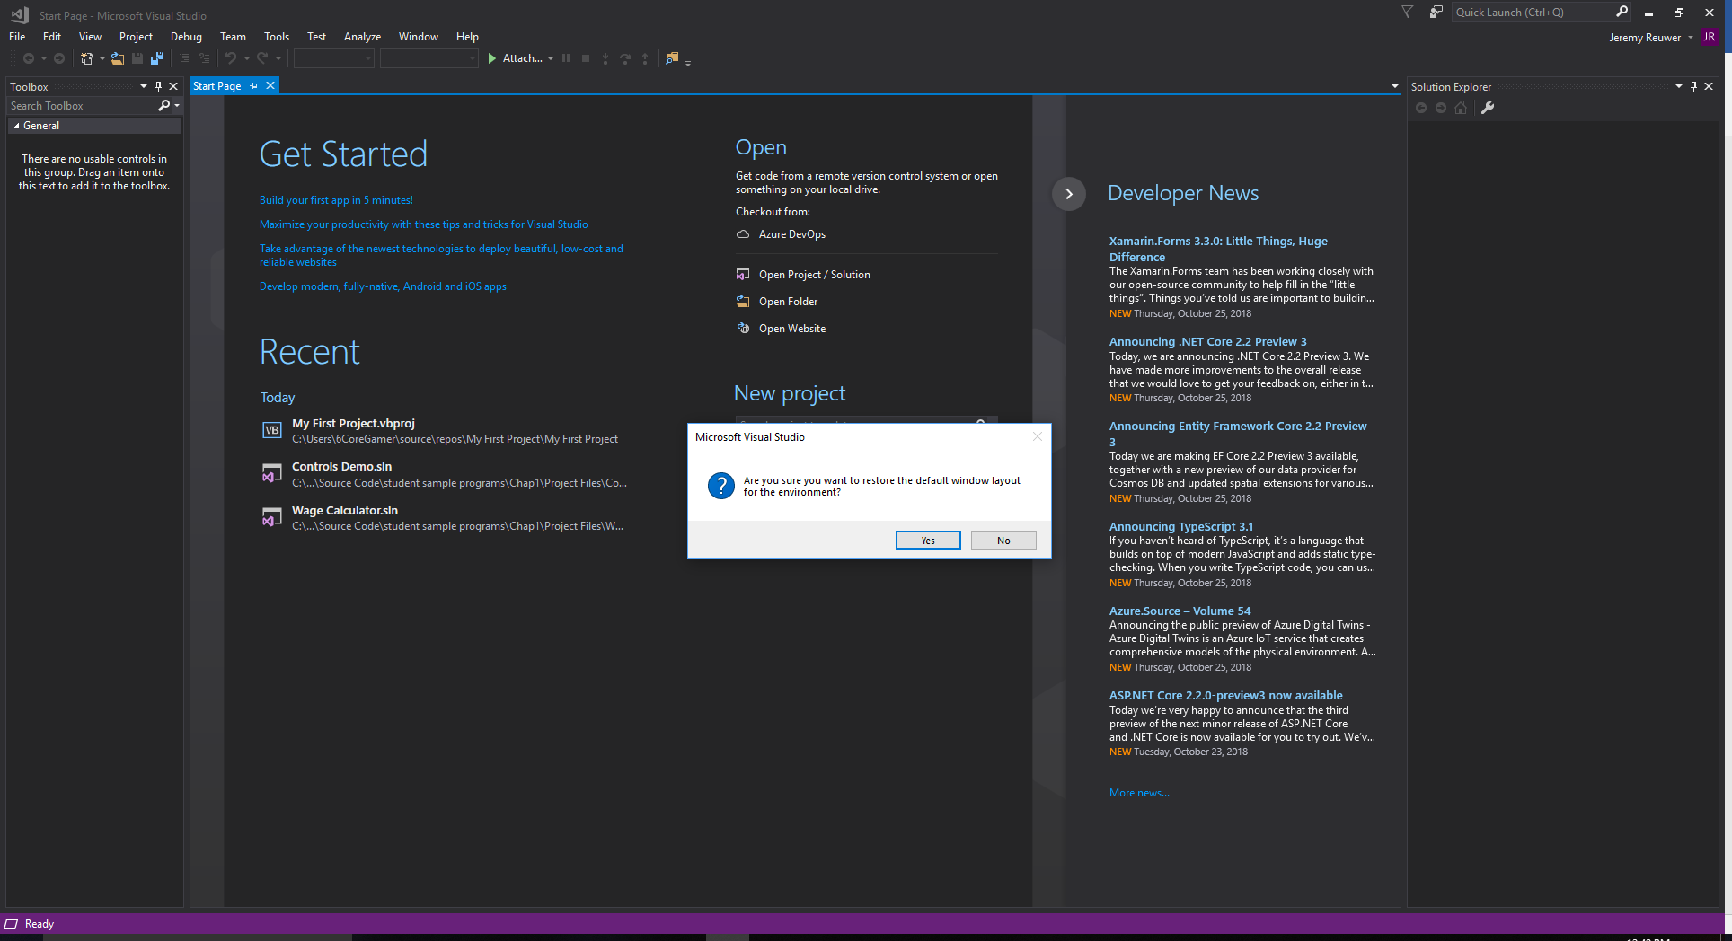

Tutorial 1-4 Get Started/The Options WIndow 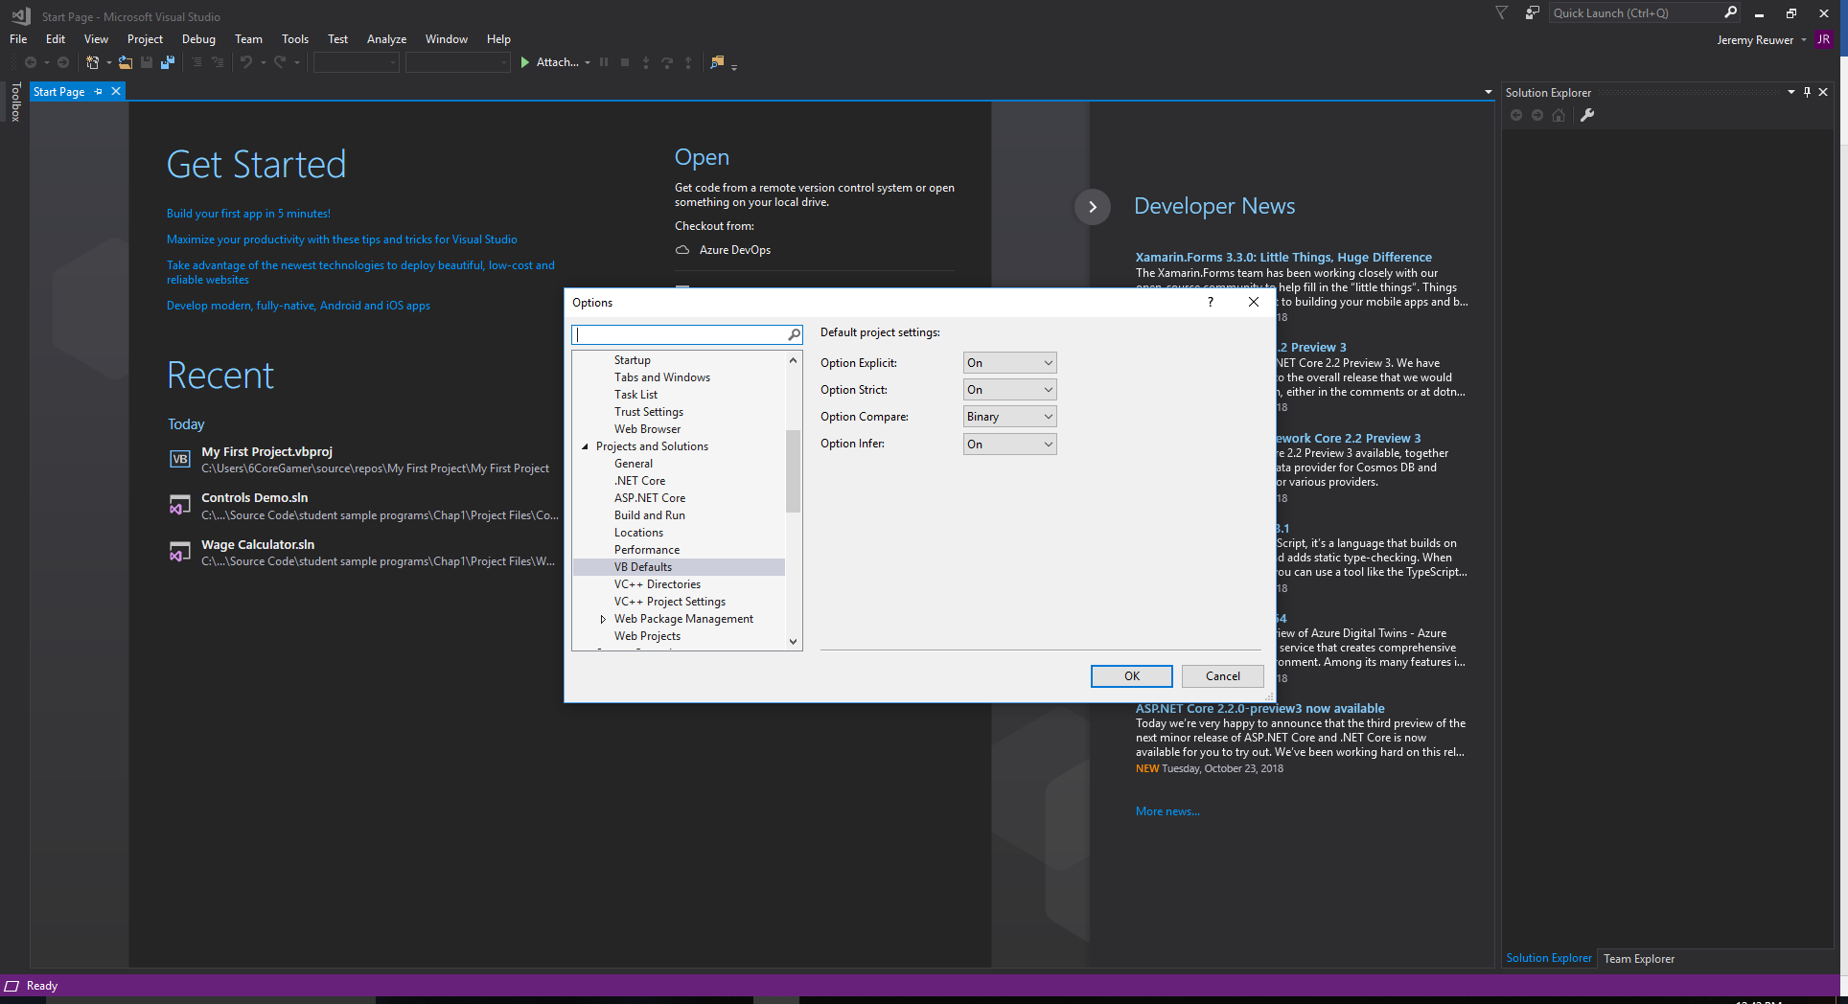

Tutorial 11-5 My First Project 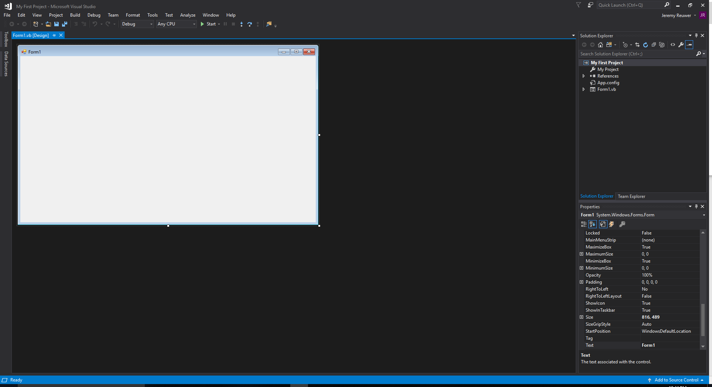

Tutorial 11-5 My First Project/All windows pinned